**Requirements for Web app**:

Need following functionalities:

* 1. Email and other written communication

We currently launch the macro and the initial screen is launched. We choose customer name, Principal on behalf of whom the communication is required and contact person required in that particular communication.

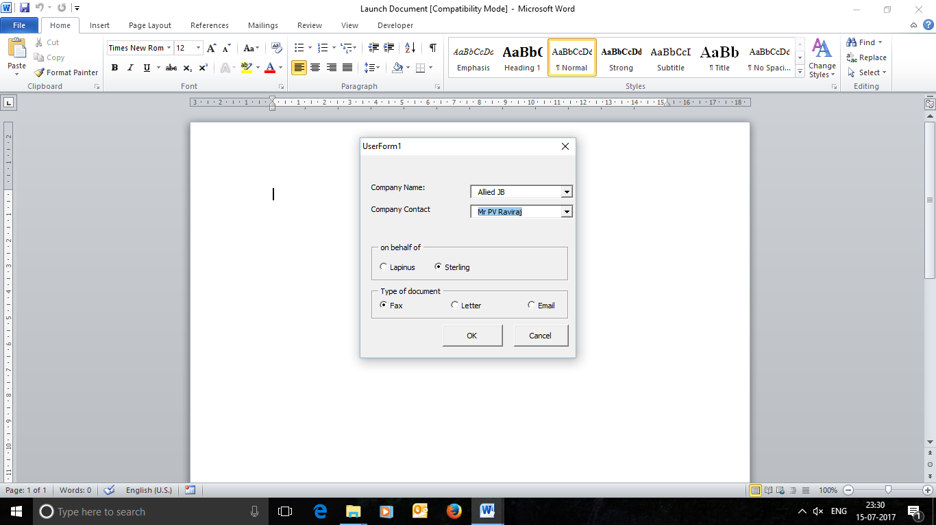

* + - This should be in a doc file. Each new communication should have a unique message no (specific to a customer)
    - Word doc should be visible and accessible to all users
    - Admin should have the sole right to delete any document. Other users cannot delete the documents
    - Document should have following format

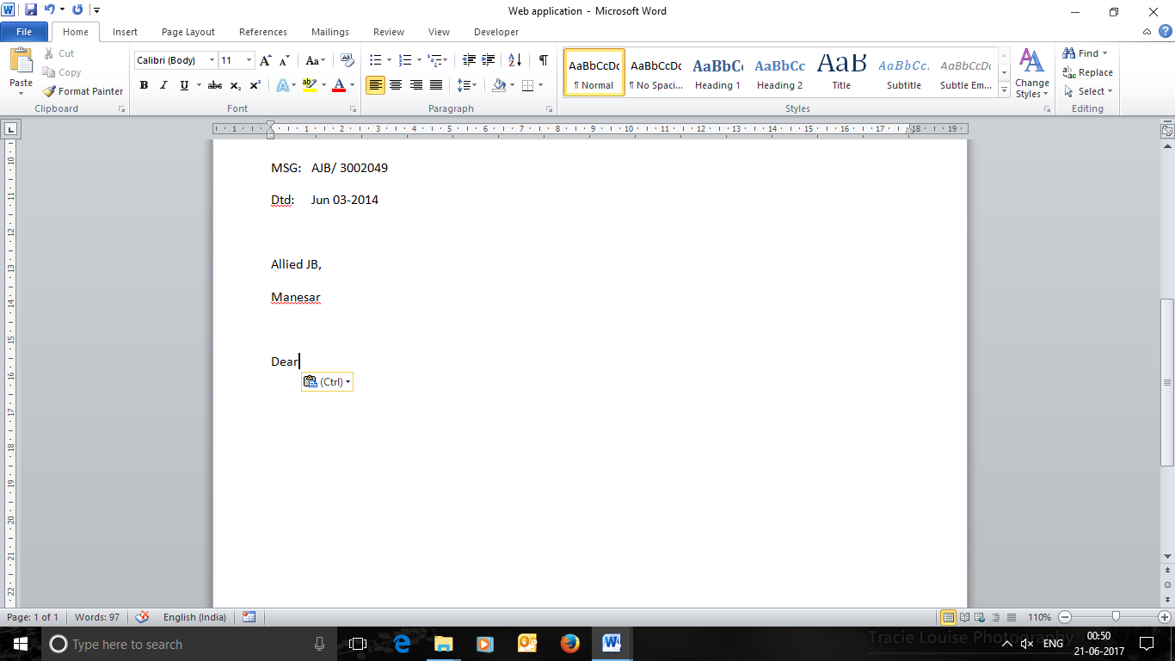

MSG ID – This should be a unique string, first part will be entered manually and will denote company name in short. Second part will be a five digit auto generated serial number starting from 00001.

Date – Should be the current date

Name of the company should be populated from database.

* 1. Order Generation

An initial screen comes up that gives option to choose Principal, Customer and Contact person for that communication. We need to give provision for 10 contacts for any Principal/Customer.

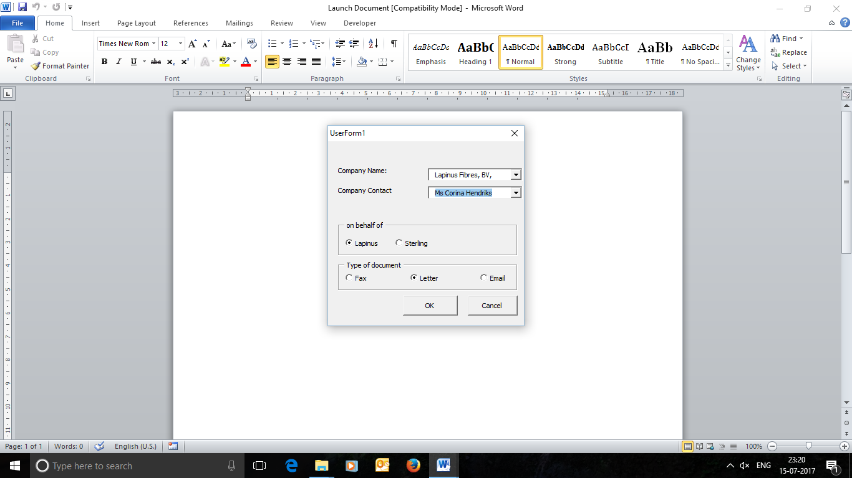

We maintain a separate doc file for each principal and append every new order in it.

1. Order generation should have following fields

* Customer: Benara Udyog

This should be a drop down list with single selection populated from db.

* Product: Promaxon D = 1680 kgs

HP 300 = 780 kgs

RB 250 = 1250 kgs

Multiple products can be selected each having different quantity.

* PO Number: Not available yet (Manual)
* Shipment: Jul wk 01/2017 (Manual)
* Payment terms: Net 60 days (Manual)
* Destination: ICD, New Delhi (Manual)

1. Order should be saved in db and appended in the word document for orders
2. The format in which it should be appended in word document is as below

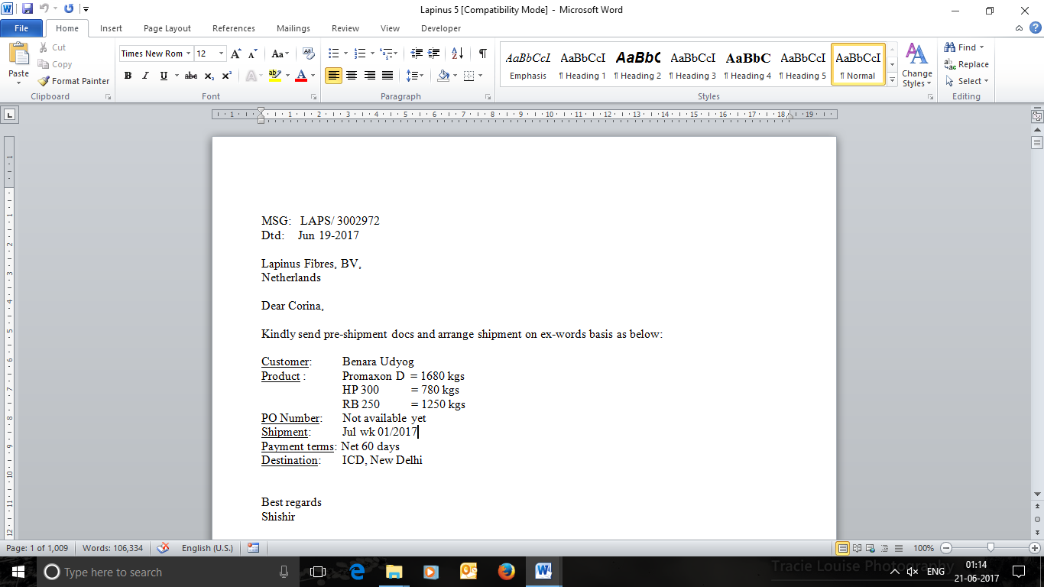

MSG – First part of the string before slash will be manual (denoting company name in short) and second part will be a five digit serial number starting from 00001

Rest all fields should be auto populated from db.

* 1. Invoice Generation

We generate an invoice every quarter for all our principals based on the sales. Format, in excel sheet, is as below:

|  |  |  |  |  |  |
| --- | --- | --- | --- | --- | --- |
| **Company** | **Product** | **Invoice no / Date** | **Quantity** | **INVOICE AMNT** | **COMMISSION** |
|  |  |  | **MT** | **Ex Works ( Euro )** | **Euro** |
|  |  |  |  |  |  |
| Allied JB | RB 250 | 5186750/Jul 11/2017 | 0.625 | 1187.5 | Xxx |

Invoice no. is generated a few days after the order is sent as the order is recorded in the system first. Commissions are based on percentage of invoice amnt and they are different for different products. We want to keep this customised, in case commission is revised in future.

Same format is generated for all principals.

* 1. Admin Role

Web app should have 2 types of login – Admin & User

* + - Client Addition
* Name of Company
* Address
* Location
* Contact person – multiple (upto 10 people)

Contact person name

Contact person designation (can be left blank also)

* + - Client deletion
    - Client Updation
    - Principal Addition
      * Name of Principal
      * Address
      * Location
      * Contact person – multiple (upto 10 people)

Contact person name

Contact person designation (can be left blank also)

* + - Principal deletion
    - Principal details updation
    - New user creation
* LoginId
* Password
* Email
* Phone number
* Address (optional)
  + - User updation and deletion
    - Order deletion/updation
  1. Report generation
     + Order history specific to a particular customer
     + Order history specific to a particular principal
     + Order history for a particular product
     + Monthly/quarterly/bi-annually and annual sales report
     + Sales report for a particular date range
     + Customer and product mapping
     + Principal and product mapping
     + Turnover details (please include price of different products so that turnover across the year/month/quarter or any other period can be calculated)
  2. User login

Following tasks are restricted for a user

* + - Deletion of any data – order, client, principal and documents
    - Creation of new user
  1. Document handling

1. A record of all orders that are received (via email) is kept to ensure that there are no discrepancies while placing an order from our side. Currently they are saved in Google Drive as follows:
   * + - Folder according to names of principals is made by prefixing with A1, A2… to maintain folder sequence

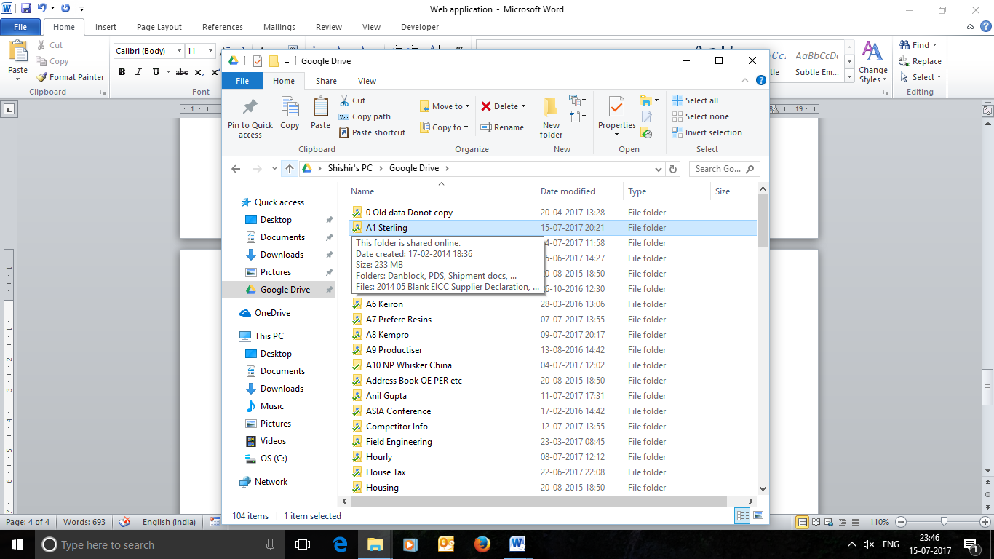

1. Year wise data is maintained

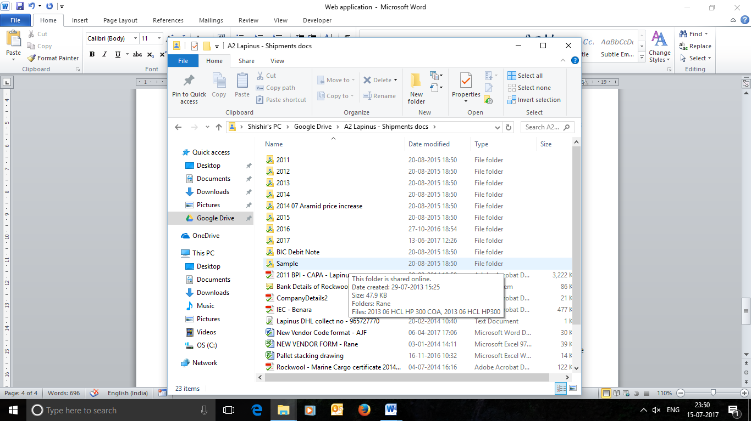

1. Order received from different customers are stored in separate folder

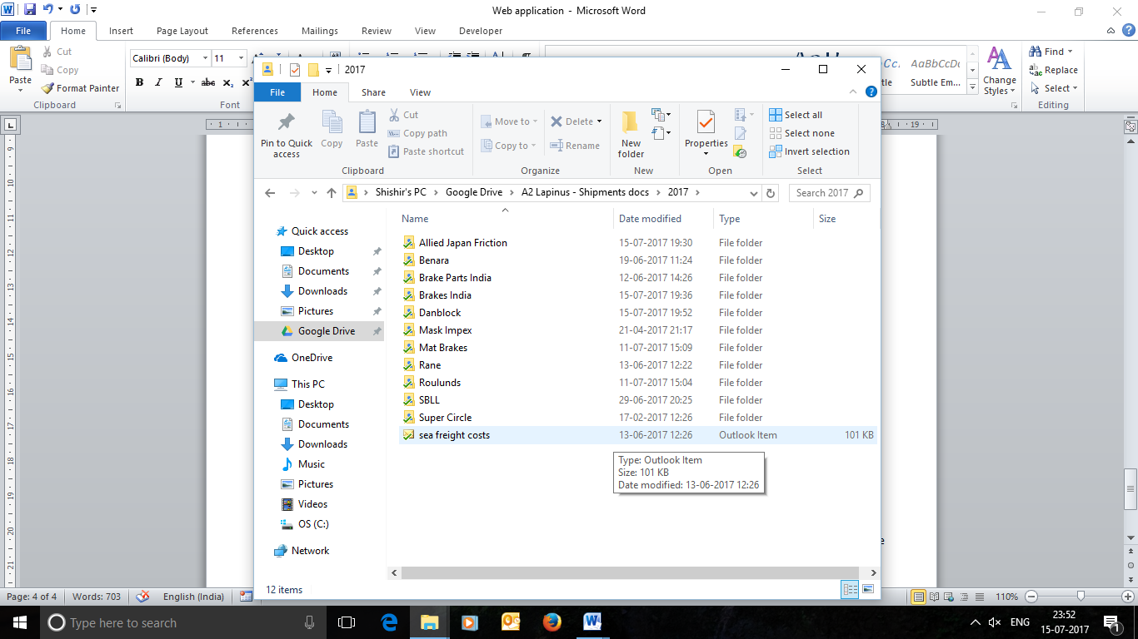

1. Specific order from every customer is stored. Folder naming convention is as per the month in which order is received

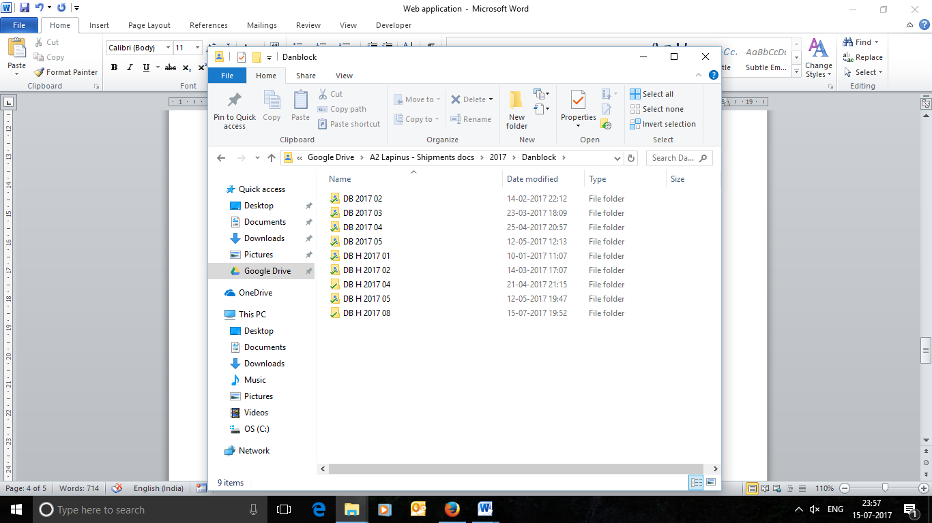

1. Documents specific to that order are further stored in each folder

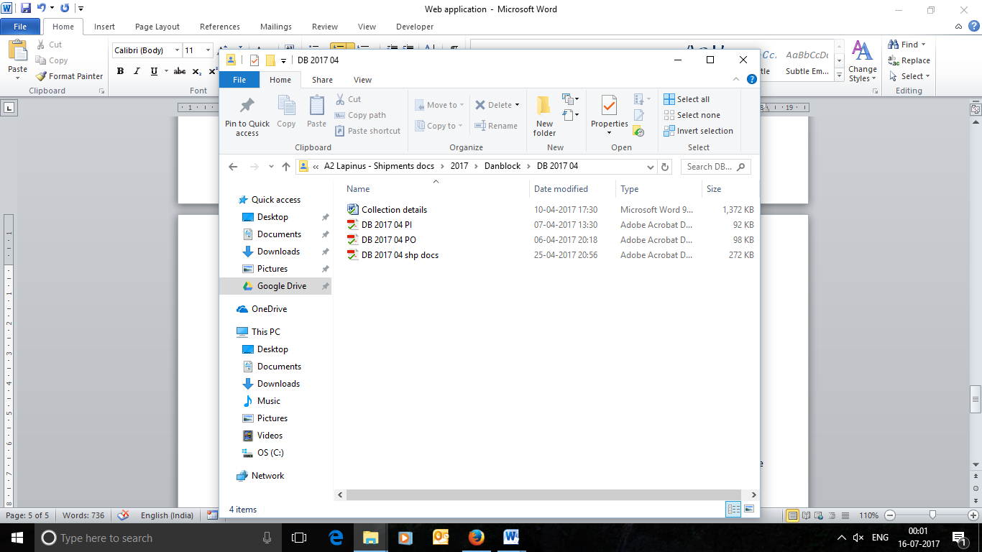

Note: Pls ensure that we can access the latest version of documents from the server. Since multiple users would be accessing the documents so there should be no conflict.